**Repeat short-interval fires continue to transform boreal forests beyond a modeled simple conifer to deciduous transition**

Katherine Hayes1, Brian Buma1

Author Affiliations:

1University of Colorado Denver, Department of Integrative Biology

* Correspondence to katherine.hayes@ucdenver.edu

Abstract:(278/350)

Warming temperatures in the boreal forest have increased wildfire frequency and severity, pushing intervals between fires below 20 years in some regions. Shortening fire intervals can drive changes in successional pathways in boreal forests. However, to date the impact of continued short interval burning (>2 events) has not been explored, nor the impact of short-interval fires in boreal deciduous forests. To investigate how ongoing short-interval fires impact conifer and deciduous post-fire regeneration, and to examine the role of landscape variability in altering that impact, we established 50 plots across a mosaic of fire histories (1, 2 or 3 fires in <70 years) in an upland and lowland site in Interior Alaska. We compared abundance, proportion and density of conifer and deciduous regeneration in a drier upland site and a wetter lowland site. Both sites were originally dominated by black spruce. In the drier upland site, black spruce presence declined sharply after two fires while paper birch (*Betula neoalaskana*) became increasingly abundant with each additional fire. In the wetter lowland site, less organic soil was consumed by fire and presence of black spruce persisted through an initial reburn (two fires), indicating local topography may buffer the impact of reburning temporarily. However, after three burns, conifers were eliminated in both upland and lowland sites. Continued reburning in deciduous stands promoted increasing dominance of deciduous species. Deciduous regeneration differed between topographic position: birch dominated in upland plots while willow (*Salix spp.)* and aspen (*Populus tremuloides*) dominated in lowlands. Results of this study offer strong empirical evidence of the divergence of boreal successional trajectories from previous historic norms and indicate the effects of reburning continue to accumulate after two or more fires.

**Keywords:** boreal, reburns, regime shifts, succession, fire frequency

# Introduction

Fire is the primary disturbance in boreal systems (Kurkowski et al. 2008), historically occurring within return intervals of ~ 100 years in Interior Alaska (Yarie 1981, Viereck 1983, Johnstone et al. 2010). Across the last six decades, increases in fire frequency has sparked concerns that shortening fire intervals (20 years or less between fires) may disrupt historic successional trajectories and lead to landscape-level shifts in forest composition and structure (Kasischke et al. 2010, Brown and Johnstone et al. 2012, Johnstone and Chapin 2006a, Young et al. 2017, Mann et al. 2012). Shifts in boreal community composition may affect permafrost stability (Mann et al. 2012), carbon storage (Alexander et al. 2012) and landscape flammability (Rupp et al. 2006).

The predominant post-fire successional pathway in boreal Interior Alaska is self-replacement (Kurkowski et al. 2008, Ott et al. 2006). Black spruce (*Picea mariana*) typically self-replaces via a large canopy seedbank after fire. The species’ssemi-serotinous cones enable dense regeneration within 10 years after fire (Kurkowski et al. 2008, Johnstone et al. 2004), allowing black spruce to continually persist under historic fire return intervals of 100 years or more (Johnstone et al. 2010). However, serotinous regeneration strategies are more vulnerable under increasing short-interval fires in boreal and other systems (Buma et al. 2013, Enright et al. 2015). Short-interval fires (essentially any return interval shorter than the time required to regenerate capacity for resilience to a fire) can consume local serotinous seedbanks, extirpating local populations and facilitating rapid forest type conversion (Buma and Wessman 2012). In the boreal specifically, the consumption of black spruceserotinous seedbanks via short fire intervals promotes an increase in deciduous trees and shrubs which have larger dispersal distances (spruce = 30m vs. most deciduous species = 60m to many kilometers depending on species; McCaughey et al. 1985, Marquis et al. 1969, Burns and Honkala 1990), allowing them to recolonize from outside burn perimeters (Brown and Johnstone 2012). Models suggest that an increase in area reburned in short intervals will lead to a shift in forest community composition from conifer-dominated stands to deciduous forest (Mann et al. 2012, Roland et al. 2019, Rupp et al. 2002) or grassland (Brooks et al. 2004, Roland et al. 2013) via declines in serotinous seedbanks.

Under shortening fire intervals, black spruce self-replacement may be further disfavored by the interactive effect of soil consumption and deciduous seed characteristics (Brown and Johnstone 2012, Johnstone and Chapin 2006a, Johnstone et al. 2009). Mature black spruce stands have deep soil organic layers, which strongly constrains regeneration of other species (Johnstone and Chapin 2006a, Greene et al. 2007). The large seeds of black spruce can withstand extreme fluctuations in temperature and moisture experienced during time spent on or in deep organic layers (Viereck 1983), which smaller seeds of deciduous species like aspen (*Populus tremuloides;* Greene and Johnson 1999*)* and birch (*Betula neoalaskana;* Zasada 1971) cannot tolerate. Repeat burning can consume deep soil organic layers entirely, negating the establishment advantage of black spruce seeds and favoring birch and aspen which produce large quantities of small wind-borne seeds that germinate directly on mineral soil surfaces (Roland et al. 2013, Johnstone et al. 2010A, Greene et al. 2007). Furthermore, continued short-interval fires may prevent the redevelopment of organic layers (which typically re-establish in conjunction with black spruce communities, Johnstone et al. 2010), further favoring deciduous species. Therefore, soil organic layer depth and exposed mineral soil are key factors influencing compositional trends in post-fire tree regeneration.

The transition of dominance from black spruce to birch and other deciduous species following two consecutive, short-interval fires has been well documented in Interior Alaska (Johnstone et al. 2004), the Yukon Territory (Brown et al. 2015, Whitman et al. 2018), Eastern Canada (Bergeron et al. 2012) and Northern Minnesota (Camill and Clark 2000, Frelich et al. 2017). These studies are primarily in gently sloped upland environments (Gibson et al. 2016, Houle et al. 2017). Successional trends in flatter and wetter lowland topographies remain underexamined, though they represent ~ 42% of boreal Interior Alaska (Douglas et al. 2014, Jorgensen and Shur 2007). The under-examination of reburns in lowlands in comparison to uplands may be partially due to the historic unlikelihood of lowlands burning (Le Goff and Sirois 2004, Whitman et al. 2019, Alexander and Mack 2015). Given the trend towards warmer and drier summers (Hinzman et al. 2005), lowland environments may begin burning more frequently. Higher soil moisture in lowlands may have an important role in moderating the effects of fire on successional pathways in lowland environments (Houle et al. 2017). Wetter site conditions may limit consumption of soil in fire events, therefore limiting the mechanism disfavoring conifer regeneration and effectively conferring additional resilience to short fire-return interval induced change. Here, we define short interval fires as <30 years because research generally suggests that 50 years or more are required for regeneration of the areal seedbank (citation).

This prior research on shortening fire intervals has been limited to single reburn events (2 fires in sequence) in conifer stands and primarily in upland mature black spruce stands. This research limits inferences regarding future boreal forest community composition for three reasons: First, the cumulative effects of three or more fires within short intervals (<20 years) on black spruce stands remains unknown, though ongoing burning is expected in the future. Second, the resilience of black spruce stands in lowland topographies to repeat short interval burning remains untested. Third, research on short-interval fires has almost entirely focused on conifer resilience, limiting our understanding of the effects of short-interval fires on deciduous stands. Given the increasing evidence that reburning leads to stands dominated by deciduous trees and shrubs (Johnstone et al. 2011, Brooks et al. 2004, Hoy et al. 2016), understanding the effects of multiple short-interval fires on emerging deciduous-dominated stands will be essential to understanding and predicting the impact of ongoing environmental and climatic change in high-latitude environments.

This study characterizes post-fire regeneration of tree species in upland and lowland stands across a gradient of 0, 1, 2 or 3 fires since 1940 occurring via a rapid increase in fire frequency boreal Interior Alaska. We hypothesize the following: continued repeat, short-interval fires will reduce conifer regeneration and favor an increase in deciduous tree regeneration in stands previously dominated by black spruce. We anticipate that plots in the well-drained, sloped upland site may be less resistant to the conifer-deciduous transition, given the theorized effect of underlying drainage conditions on soil consumption during fire. Finally, we hypothesize that repeat subsequent burning (3 fires in sequence in short intervals) in newly transitioned or emerging deciduous stands will cement successional trends in favor of deciduous species.

# Methods

## Site Selection

We established 50 20x20m plots in the summers of 2018 and 2019 between an upland and lowland location in Interior Alaska in pre-fire black spruce forest types (Fig. 1). Using historical aerial photographs, burn history (Alaska Large Fire Database, FRAMES, 2018), and modern remotely sensed fire perimeters (Monitoring Trends in Burn Severity database, MTBS), we identified pre-fire mature black spruce stands that experienced one to three severe (meaning complete aboveground mortality) fires in the last 60 years; all stands underwent the final burn in 2004 or 2005 (Table S1). Plots represented four specific reburn histories: 1) mature unburned black spruce forest stands (n = 8; Fig. 2A), 2) once-burned black spruce forest recovering from a single short-interval fire (n = 15, ~15 years ago, Fig. 2B), 3) twice-burned black spruce forest recovering from two short-interval fires (n = 15, one ~15 years ago, and the second ~30 years ago, Fig. 2C), and 4) thrice-burned black spruce forest (n = 12, burned once ~15 years ago, a second time ~30 years ago and finally a third ~45 years ago; Fig. 2D). For the earliest fires, pre-fire composition and complete aboveground mortality at a plot was inferred via the historical photographs and verified via wood anatomy/tree ages (to ensure no survivors from previous fires) where possible (data not shown). Fires were of comparable size and severity (Table S1).

## Site Locations and History

Plots were randomly placed within described burn histories, with a minimum of 50 meters spacing and a minimum of 100 meters away from unburned legacies to control for black spruce dispersal distances. Plots were stratified evenly between two topographic positions: an upland and lowland location. The upland site (n = 26) represents well-drained, gently sloped (slope 3-13 degrees) boreal forest topographies; the lowland (n = 24) a flatter (slope = 0.3-2.6 degrees) and more poorly drained environment (Fig. S1). Plots were climatically similar (Table S2; Western Regional Climate Center). Both are on the northern edge of the discontinuous permafrost zone and nearby unburned black spruce communities have shallow permafrost in both locations (data not shown).

## Field Sampling

To determine the impact of repeat short-interval fires on conifer and deciduous post-fire regeneration, we surveyed density, basal area and species composition of tree species on each plot. For all individuals above diameter at breast height (DBH; or 1.37 meters), we recorded species, diameter, and condition (live or dead). Where density precluded counting over the entire 400 m2, a randomly selected subset (100 or 200 m2) was counted and scaled accordingly. We recorded presence, species and condition of seedlings that fell below 1.37 meters across ten 1 m2 sections randomly placed on each plot. For asexual reproducers like willow and aspen, each individual stem in a given clump was counted; clumps and their characteristics (including basal area) were pooled and treated as individuals in order to avoid overestimating abundance of regeneration events.

We then calculated three metrics of regeneration: 1) density (number of stems per hectare), 2) basal area (square meters per hectare) and 3) the relative proportion of species present within a plot. The drivers and implications of changes in tree density, tree basal area and tree proportion are distinct and meaningful: stem density represents post-fire stand structure, basal area indicates trends in overall biomass and the proportion of tree species present on a plot signals stand-level patterns in post-fire tree community composition.

To characterize soil characteristics across the burn histories, we evaluated organic layer depth and percent cover of exposed mineral soil. Organic layer depth was measured at the center and at each corner of each plot. Percent cover of organic and exposed mineral soil surfaces were estimated across 1-meter subplots at each corner of each site. To infer soil consumption in the most recent fire, distance from adventitious roots (opportunistic, lateral roots produced after initial root system development) to current soil surface was measured where snags with such roots were available to sample following the approach of Kasischke and Johnstone 2005.

## Data Analysis

Differences in tree regeneration across reburn history and between upland and lowland sites were evaluated using the nonparametric Kruskal-Wallis test, followed by pairwise comparisons using Dunn’s test with Bonferroni corrected p-values (Dinno 2015).

We used linear mixed effect models (LMEs) to investigate whether the effects of repeat short interval fires on conifer and deciduous regeneration differ according to topographic position. Our predictor variables were number of fires and/or topographic position while our response variables were density or basal area of either conifer or deciduous species. Plot number was included as a random effect to account for unmodeled variance between individual plots. We modeled two metrics of conifer and deciduous tree regeneration (density and basal area) using LMEs of increasing complexity. First, we modeled regeneration using either number of fires or topographic position as an explanatory variable. Then, we tested whether number of fires interacted with topographic position to impact regeneration by modeling tree regeneration with and without an interaction effect between the two and evaluating subsequent AIC and BIC values.

To examine whether post-fire tree regeneration within fire histories was impacted further by topographic or post-fire soil characteristics, we hierarchically tested linear mixed effect models containing those attributes as fixed effects. We accounted for the variation explained by fire or topographic position by treating them as random effects, allowing us to focus on any potential additional effect of local topographic or soil characteristics. Fixed effects included the following topographic and soil characteristics: slope, total annual solar radiation, average organic layer depth, and average exposed mineral soil. Slope and solar radiation for each site were calculated using IFSAR digital elevation models from the Alaska mapping initiative (USGS 2019, 5m). Elevation, while an important factor driving tree community composition in Alaska, was not included as a variable since it did not vary meaningfully across plots (Fig. S1B). All fixed effects were standardized (mean zero, SD 1) using the ‘effectsize’ package in R to allow for direct comparison of effect size magnitude (Makowski et al. 2019). Overall model fit was evaluated using AIC and BIC values.

All analysis, model fit, and selection were performed in R-Studio version 1.2.1335 (R Development Core Team, 2018) and reported means include one standard deviation. Linear mixed models were conducted using ‘lme4’ (Bates et al. 2019). Because our plots are clustered by design to take advantage of natural experimental conditions, spatial autocorrelation among plots was assessed using Moran’s I (Moran 1950). We found evidence of spatial autocorrelation within tree data of lowland plots but accounted for autocorrelation by including plot number as a random effect in LMEs (Table S4).

# Results

Unburned plots were dominated by conifers, by design. Both conifer basal area and density were significantly higher in unburned upland sites compared to lowland counterparts (Dunn’s test, basal area p = <0.001, density p = <0.001; Fig. 3).

## Post-fire conifer and deciduous density

Total tree density was highest in unburned plots in both sites (mean 2,622 stems per ha, SD 1,568 in uplands and 1,222 stems/ha, SD 703 in lowlands) and declined overall with continued reburning in both upland and lowland plots (Fig. 5). Conifer density declined sharply after one fire in both sites and remained low with each additional fire. The pattern of pairwise differences in deciduous density differed between upland and lowland plots: density of deciduous species increased significantly after 2 fires in upland plots (p= <0.001) but did not increase significantly until after three fires in lowland counterparts (p = <0.001) (Table S6).

## Post-fire conifer and deciduous basal area

Similar to tree density, conifer basal area declined significantly after one fire in both sites and never recovered (Dunn’s test, upland p = <0.001, lowland p = <0.001) (Fig. 6). After one fire, deciduous basal area increased significantly with each reburn in both sites (Fig. 6). Total basal area of reburned plots never recovered to unburned levels (Table S6).

## Patterns in species presence

All burned sites were dominated in abundance by deciduous species (Fig. 4). Once-, twice- and thrice-burned upland canopies were predominantlybirch, while the canopies in burned lowland plots differed across reburn sequence: once-burned lowland canopies were dominated by willow, canopies in twice-burned lowland plots were primarily birch while thrice-burned lowland canopies were predominantly composed of aspen (Table S5). While both the upland and lowland site are dominated by deciduous species after two fires, each is dominated by a different species.

## Post-fire soil characteristics across reburns

Adventitious roots were only available to sample in once- and twice-burned plots, as three burn plots had no black spruce snags left to assess. Depth of adventitious roots implied greater inferred soil consumption in upland plots, particularly after one fire (Fig. 7A).

Despite similar depths in unburned locations, lowland organic-layers were thicker than upland layers regardless of number of reburns by a factor of 1.6, and the difference between the two topographic positions was largest in twice-burned plots where lowland organic-layers were larger by a factor of 3.2 (Fig. 7). The decline in organic layer depth occurs faster in upland plots than in lowland plots: organic layers were reduced by a factor of 3.2 after one fire in upland plots, but only by a factor of 1.8 in lowland plots (Fig. 7B). Similar trends exist in exposed mineral soil: upland plots had no exposed mineral soil in unburned plots but saw an increase in the amount of exposed mineral soil, up to 100% in some thrice-burned plots (Fig. 7C).

## Impact of repeat fires and topography on tree regeneration

Based on analysis of LMEs, density and basal area of conifer and deciduous species were controlled by different factors. Conifer density, conifer basal area and deciduous density were primarily driven by number of fires, while deciduous basal area was best described by topographic position. In every case, model fit (as evaluated by AIC and BIC values) improved when number of fires and topographic position were held as separate effects (rather than interacting terms), and in models of conifer density, basal area and deciduous density, model fit improved when topographic position was dropped entirely (Table S6). For three out of four metrics, including topographic position as a fixed or interactive effect did not improve model fit. This indicates that 3 short-interval fires had similar effects on deciduous and conifer post-fire regeneration in both the upland and lowland site. In both sites, conifer tree density and conifer basal area decreased with more reburns. Increasing short-interval fires lead to greater deciduous density in both upland and lowland sites (Fig. 5 and 6). Topographic position was the best predictor of deciduous basal area.

## Impact of topographic and post-fire soil characteristics on tree regeneration

After accounting for the variation explained by reburn sequence, the primary factors driving post-fire tree density of conifers were organic layer depth (effect size -11.82, p= 0.03) followed by average exposed mineral soil (effect size -5.09, p = 0.07) (Table 3). Conifer basal area was positively driven by slope (+1.75, p = 0.02) and solar radiation (+3.85, p < 0.01) but negatively affected by average organic layer depth (-3.04, p < 0.01) as hypothesized. Deciduous tree density was positively driven by slope (+484.8, p < 0.01) and negatively impacted by average organic layer depth (-349.8, p = 0.02) and exposed mineral soil (-340.1, p < 0.01) while deciduous basal area was primarily impacted by average organic layer depth (-56.93, p < 0.01) and slope (+19.3, p < 0.01 ) (Table 2 and 3). Overall, steeper slopes were associated with greater deciduous densities and conifer and deciduous basal area within burned stands. Deeper organic layers negatively affected all metrics of tree regeneration. A greater proportion of exposed mineral soil significantly decreased tree densities of both conifers and deciduous species.

# Discussion

We provide the first look at reburning in emerging deciduous stands. Our results indicate that major shifts in forest composition and structure caused by reburning continue after two fires and that new effects begin to emerge with three short-interval fires. The species present within deciduous trajectories differed between topographic position, indicating the importance of local topography in determining specific successional outcomes after fire. Furthermore, our results specifically indicate a disruption of self-replacement trajectories occurring even in a wetter lowland site, previously thought to be more resistant or resilient to transition.

Our two primary objectives were to characterize post-fire tree regeneration in sites that experienced up to three short interval fires and to investigate whether the effect of fire differed in upland and lowland sites (via differences in local topographic and soil characteristics). Reburned stands in this study were predominantly composed of deciduous species, though the specific assemblages of species differed between the upland and lowland site and by number of reburn events. Conifer populations declined later in the reburn sequence in the lowland site, suggesting that local site conditions may allow conifers to persist for longer under repeated short-interval fires. Three reburns moved the lowland landscape across a critical threshold from a small but persistent conifer population to a locally extirpated conifer presence, similar to upland counterparts. This indicates the significant impact of short interval reburning continues and new impacts continue to emerge after 2+ fire events.

Patterns of post-fire soil characteristics differed between sites as hypothesized: upland plots had substantially thinner organic layers and more exposed mineral soil than lowland equivalents, but organic layer thickness decreased with greater burn frequency in both locations. Given the role of burn severity in altering competitive interactions between coniferous and deciduous species, this variation between topographic position indicates that black spruce may retain competitive advantage longer in lowland sites under single burn or reburn events. Soil organic layers persisted for longer in lowland plots. However, lowland plots still underwent a transition from conifer to deciduous, indicating potential resilience provided by lower levels of soil consumption is limited to single burn or reburn events.

Stand characteristics differed across reburn sequence and between topographic position. Upland plots displayed consistently higher tree density and basal area than lowland counterparts, but in both sites, both basal area and tree density never returned to pre-fire levels. Changes in stand density imply a change in stand structure, which has implications for landscape characteristics like aboveground carbon storage and landscape flammability. Given that fuel will play a central role in ongoing boreal fire regime change, understanding the influence of decreasing stand density on local fuel loads and structure will be crucial to managing and predicting future fire behavior in reburned stands (Higuera et al. 2008).

Species-specific trends in tree occupation, density and abundance differed between upland and lowland sites: upland reburned plots were composed of willow and birch in higher abundance and densities than comparable lowland plots and experienced a decline in black spruce earlier in the sequence of reburns. Black spruce populations declined slower in lowland plots and were replaced by aspenand willow after three fires. This divergence suggests that both site-level differences in drainage conditions and reburning effects play an important initial role in determining species-specific successional outcomes in boreal forests – and that the effects of reburning continue to accrue after the 2nd event.

The spatial extent of a shift towards a deciduous-dominated boreal remains unknown: a boreal transition towards deciduous communities appears to be spatially constrained to site- or fire-level effects (Roland et al. 2019). The results of this study are similarly limited in scale. However, these results contribute to the growing body of evidence of site-level successional trajectory disruption caused by short-interval reburns. Our work presents several key inferences. First, low quantities of black spruce seedlings in twice- and thrice-burned plots suggests a potential local extirpation of black spruce seed sources. Second, organic soil layers in both sites were consumed during each reburn, even in the wetter lowland site, leading to increased exposure of mineral soil surfaces. No organic layer in reburned plots of either site has recovered to inferred pre-fire depth, even 15 years post-fire. Finally, we found that deciduous communities emerged in both upland and lowland sites after multiple repeat short-interval fires, replacing original black spruce communities entirely. Together, these patterns suggest that repeat burning leads to a meaningful disruption of existing successional trends despite proposed local resiliency via poorly drained lowland conditions, and that repeat burning in emerging deciduous post-fire communities not only can occur but continues to drive community shifts towards dominance of deciduous trees and shrubs partly facilitated by removal of organic soil layers and surfaces. both coniferous and deciduous forests, as it appears the widely anticipated reduction in fire return intervals will continue to change forest structure and function beyond the initial short-interval effects and regardless of initial local resiliency.

# Conclusions

Current trends in tree regeneration indicate that boreal forest successional trajectories have become untethered from regional legacy conditions. Low abundance of black sprucein reburned plots suggests the prevention of self-replacement as a future successional pathway in our specific sites. Furthermore, deciduous species are emerging in assemblages novel to Interior Alaska boreal forests after ongoing short-interval burning: the strong presence of willow and aspen in particular indicate the emergence of not only a species-replacement successional trajectory, but a species-replacement successional trajectory much more in line with primary successional trends than secondary. The unique perspective of this study demonstrates ongoing changes to disturbance regimes continue to drive quantitatively different outcomes compared to single, short-interval events, and therefore questions regarding community resilience to future climate change effects must explicitly consider unfolding, emerging, and ongoing changes, not just snapshots in time.

# Acknowledgements

This research was supported by

Thank you to K. Olson, V. Kodicherla, K. Martini and K. Turchick for assistance in the field

# Literature Cited

*Alaska*, Western Regional Climate Center, 2020. Web. 22 March 2020. <https://wrcc.dri.edu/wraws/akF.html>

*Alaska Large Fire Database,* Alaska Fire Service, Fire Research and Management Exchange System. 2018. Web. March 2018. https://www.frames.gov/catalog/10465

Alexander, Heather D., and Michelle C. Mack. "A canopy shift in interior Alaskan boreal forests: consequences for above-and belowground carbon and nitrogen pools during post-fire succession." *Ecosystems* 19.1 (2016): 98-114.

Bates, Douglas M. "lme4: Mixed-effects modeling with R." (2010): 470-474.

Bergeron, Yves, and Nicole J. Fenton. "Boreal forests of eastern Canada revisited: old growth, nonfire disturbances, forest succession, and biodiversity." *Botany* 90.6 (2012): 509-523.

Brooks, Matthew L., et al. "Effects of invasive alien plants on fire regimes." *BioScience* 54.7 (2004): 677-688.

Brown, Carissa D., et al. "Disentangling legacy effects from environmental filters of postfire assembly of boreal tree assemblages." *Ecology* 96.11 (2015): 3023-3032.

Brown, Carissa D., and Jill F. Johnstone. "Once burned, twice shy: Repeat fires reduce seed availability and alter substrate constraints on Picea mariana regeneration." *Forest Ecology and Management* 266 (2012): 34-41.

Buma, Brian, et al. "The impacts of changing disturbance regimes on serotinous plant populations and communities." *BioScience* 63.11 (2013): 866-876.

Buma, B., and C. A. Wessman. "Differential species responses to compounded perturbations and implications for landscape heterogeneity and resilience." *Forest Ecology and Management* 266 (2012): 25-33.

Burns, Russell M., and Barbara H. Honkala. "tech. coords.(1990). Silvics of North America: 1. Conifers; 2. Hardwoods. Agricultural Handbook 654." *US Department of Agriculture, Forest Service. Washington DC* 2: 877.

Camill, Philip, and James S. Clark. "Long-term perspectives on lagged ecosystem responses to climate change: permafrost in boreal peatlands and the grassland/woodland boundary." *Ecosystems* 3.6 (2000): 534-544.

Dinno, Alexis. "Nonparametric pairwise multiple comparisons in independent groups using Dunn's test." *The Stata Journal* 15.1 (2015): 292-300.

Douglas, Thomas, et al. "Sources and sinks of carbon in boreal ecosystems of interior Alaska: A review." *Elem Sci Anth* 2 (2014).

Enright, Neal J., et al. "Interval squeeze: altered fire regimes and demographic responses interact to threaten woody species persistence as climate changes." *Frontiers in Ecology and the Environment* 13.5 (2015): 265-272.

Frelich, Lee E., Peter B. Reich, and David W. Peterson. "The changing role of fire in mediating the relationships among oaks, grasslands, mesic temperate forests, and boreal forests in the Lake States." *Journal of Sustainable Forestry* 36.5 (2017): 421-432.

Gibson, Carolyn M., et al. "Variation in plant community composition and vegetation carbon pools a decade following a severe fire season in interior Alaska." *Journal of vegetation science* 27.6 (2016): 1187-1197.

Greene, D. F., and E. A. Johnson. "Modelling recruitment of Populus tremuloides, Pinus banksiana, and Picea mariana following fire in the mixedwood boreal forest." *Canadian Journal of Forest Research* 29.4 (1999): 462-473.

Greene, David F., et al. "The reduction of organic-layer depth by wildfire in the North American boreal forest and its effect on tree recruitment by seed." *Canadian Journal of Forest Research* 37.6 (2007): 1012-1023.

Higuera, Philip E., et al. "Frequent fires in ancient shrub tundra: implications of paleorecords for arctic environmental change." *PloS one* 3.3 (2008).

Hinzman, Larry D., et al. "Evidence and implications of recent climate change in northern Alaska and other arctic regions." *Climatic change* 72.3 (2005): 251-298.

Houle, Gregory P., et al. "Recovery of carbon pools a decade after wildfire in black spruce forests of interior Alaska: effects of soil texture and landscape position." *Canadian Journal of Forest Research* 48.1 (2017): 1-10.

Hoy, Elizabeth E., Merritt R. Turetsky, and Eric S. Kasischke. "More frequent burning increases vulnerability of Alaskan boreal black spruce forests." Environmental Research Letters 11.9 (2016): 095001.

Johnstone, Jill F., and F. Stuart Chapin. "Effects of soil burn severity on post-fire tree recruitment in boreal forest." *Ecosystems* 9.1 (2006): 14-31. A

Johnstone, J. F., and F. S. Chapin. "Fire interval effects on successional trajectory in boreal forests of northwest Canada." *Ecosystems* 9.2 (2006): 268-277. B

Johnstone, Jill F., et al. "Decadal observations of tree regeneration following fire in boreal forests." *Canadian Journal of Forest Research* 34.2 (2004): 267-273.

Johnstone, Jill F., et al. "Changes in fire regime break the legacy lock on successional trajectories in Alaskan boreal forest." *Global Change Biology* 16.4 (2010): 1281-1295.

Johnstone, Jill, et al. "Postfire seed rain of black spruce, a semiserotinous conifer, in forests of interior Alaska." *Canadian Journal of Forest Research* 39.8 (2009): 1575-1588.

Johnstone, Jill, et al. “Modeling impacts of fire severity on successional trajectories and future fire behavior in Alaskan boreal forests.” *Landscape Ecology*, 26.4 (2011).

Jorgenson, M. Torre, and Yuri Shur. "Evolution of lakes and basins in northern Alaska and discussion of the thaw lake cycle." *Journal of Geophysical Research: Earth Surface* 112.F2 (2007).

Kasischke, E. S., & Johnstone, J. F. (2005). Variation in postfire organic layer thickness in a black spruce forest complex in interior Alaska and its effects on soil temperature and moisture. *Canadian Journal of Forest Research*, *35*(9), 2164-2177.

Kasischke, Eric S., and Merritt R. Turetsky. "Recent changes in the fire regime across the North American boreal region—Spatial and temporal patterns of burning across Canada and Alaska." Geophysical research letters 33.9 (2006).

Kasischke, Eric S., et al. "Alaska’s changing fire regime—implications for the vulnerability of its boreal forests." *Canadian Journal of Forest Research* 40.7 (2010): 1313-1324.

Kurkowski, Thomas A., et al. "Relative importance of different secondary successional pathways in an Alaskan boreal forest." Canadian Journal of Forest Research 38.7 (2008): 1911-1923.

Goff, Héloïse Le, and Luc Sirois. "Black spruce and jack pine dynamics simulated under varying fire cycles in the northern boreal forest of Quebec, Canada." *Canadian Journal of Forest Research* 34.12 (2004): 2399-2409.

Makowski D, Lüdecke D (2019). “Compute and interpret indices of effect size.” *CRAN*. R package, <https://github.com/easystats/effectsize>.

Mann, Daniel H., et al. "Is Alaska’s boreal forest now crossing a major ecological threshold?." *Arctic, Antarctic, and Alpine Research* 44.3 (2012): 319-331.

Marquis, D. A., Solomon, D. S., & Bjorkbom, J. C. (1969). *A silvicultural guide for paper birch in the Northeast*. US Department of Agriculture, Forest Service, Northeastern Forest Experiment Station.

McCaughey, Ward W., Wyman C. Schmidt, and Raymond C. Shearer. "Seed-dispersal characteristics of conifers in the inland mountain west." (1985).

Moran, P. A. (1950). Notes on continuous stochastic phenomena. *Biometrika*, *37*(1/2), 17-23.

MTBS Data Access: Fire Level Geospatial Data. (2017, July – last revised. MTBS Project (USDA Forest Service/U.S. Geological Survey). <http://mtbs.gov>

Ott, L. A. V. R. A., P. C. A. D. Mann, and Keith Van Cleve. "Successional processes in the Alaskan boreal forest." *Alaska’s changing boreal forest* (2006): 100.

Roland, Carl A., Joshua H. Schmidt, and E. Fleur Nicklen. "Landscape‐scale patterns in tree occupancy and abundance in subarctic Alaska." *Ecological Monographs* 83.1 (2013): 19-48.

Roland, Carl A., et al. "Regional variation in interior Alaskan boreal forests is driven by fire disturbance, topography, and climate." *Ecological Monographs* (2019): e01369.

Rupp, T. Scott, et al. "Modeling the impact of black spruce on the fire regime of Alaskan boreal forest." *Climatic Change* 55.1-2 (2002): 213-233.

USGS National Geospatial Program. *Interferometric Synthetic Apeture Radar (IFSAR) Alaska.* DEM. Accessed November 2018. <https://catalog.data.gov/dataset/interferometric-synthetic-aperture-radar-ifsar-alaska>.

|  |
| --- |
|  |

Viereck, L. A. "The effects of fire in black spruce ecosystems of Alaska and northern Canada." *The role of fire in northern circumpolar ecosystems, Wiley, New York, USA* (1983): 210-220.

Walker, Xanthe J., et al. "Soil organic layer combustion in boreal black spruce and jack pine stands of the Northwest Territories, Canada." *International Journal of Wildland Fire* 27.2 (2018): 125-134.

Whitman, Ellen, et al. "Topoedaphic and forest controls on post-fire vegetation assemblies are modified by fire history and burn severity in the Northwestern Canadian Boreal Forest." *Forests* 9.3 (2018): 151.

Whitman, Ellen, et al. "Short-interval wildfire and drought overwhelm boreal forest resilience." *Scientific Reports* 9.1 (2019): 1-12.

Yarie, John. "Forest fire cycles and life tables: a case study from interior Alaska." *Canadian Journal of Forest Research* 11.3 (1981): 554-562.

Young, Adam M., et al. "Climatic thresholds shape northern high‐latitude fire regimes and imply vulnerability to future climate change." Ecography 40.5 (2017): 606-617.

Zasada, John C. "Natural regeneration of interior Alaska forests-seed, seedbed, and vegetative reproduction considerations." *Proceedings, fire in the northern environment. USDA Forest Service, Pacific Northwest Forest Range Experimental Station, Portland, OR* (1971): 231-246.

Figure 1.Sampled wildfires and field site locations within Interior Alaska. Fire perimeters displayed in color and marked with year of fire. Highways marked with black line (Dalton highway in the Upland site, Steese Highway in the Lowland). Coordinates included are approximate.



Figure 2.Pictures of study sites. A) Unburned mature black spruce stand. B) Once-burned former black spruce stand, 15 years since last fire C) Twice-burned former black spruce stand, 15 years since last fire. D) Thrice-burned former black spruce stand, 16 years since last fire. Labels on the image describe years of fire and number of plots investigated.

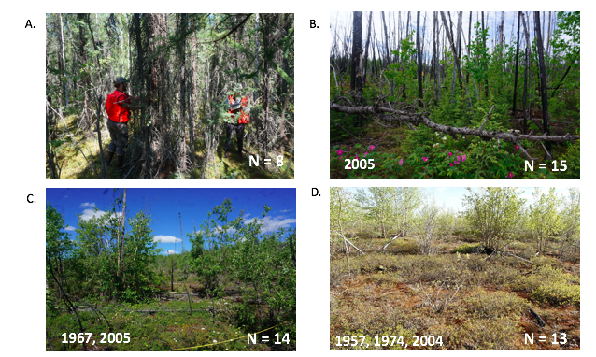

Figure 3.Density (stems/ha) and basal area (m/ha) of unburned reference plots in upland and lowland site. Plot A shows the distribution of basal area of conifer and deciduous species in unburned upland and lowland plots. Plot B shows the range of density of deciduous and conifer individuals in unburned upland and lowland plots.

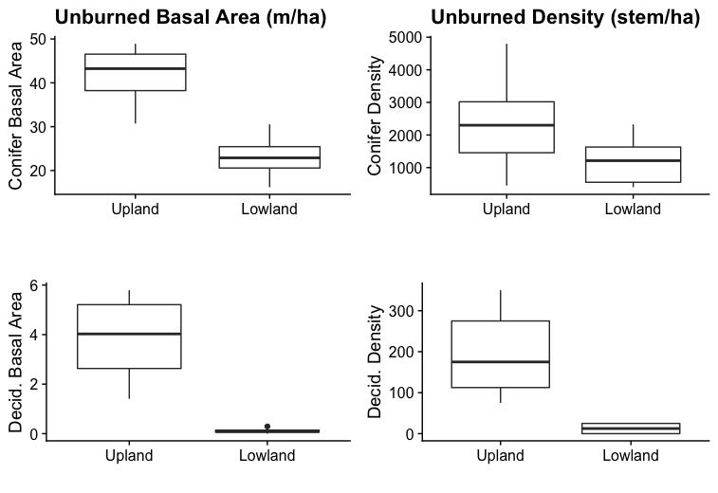

Figure 5**.** Conifer and deciduous tree density (stems/ha) across reburn sequence and between upland and lowland sites. Results from Dunn’s multiple pairwise comparison test shown where differences were significant. Only sequential comparison results presented. Significance of effect indicated as follows: *** p ≤ 0.001, ** p ≤ 0.01, * p ≤ 0.05. Conifer outliers above 50 stems/ha removed.



Figure 6.Conifer and deciduous tree basal area (m2/Ha) across reburn sequence and between upland and lowland sites. Results from Dunn’s multiple pairwise comparison test shown where differences were significant. Only sequential comparison results presented. Significance of effect indicated as follows: *** p ≤ 0.001, ** p ≤ 0.01, * p ≤ 0.05. Conifer outliers above 0.05 m/ha removed.



Figure 4.Average proportion of trees and seedlings of species present on a plot across reburn sequence between upland and lowland plots. Error bars represent standard deviations and center points represent mean within reburn history and site.

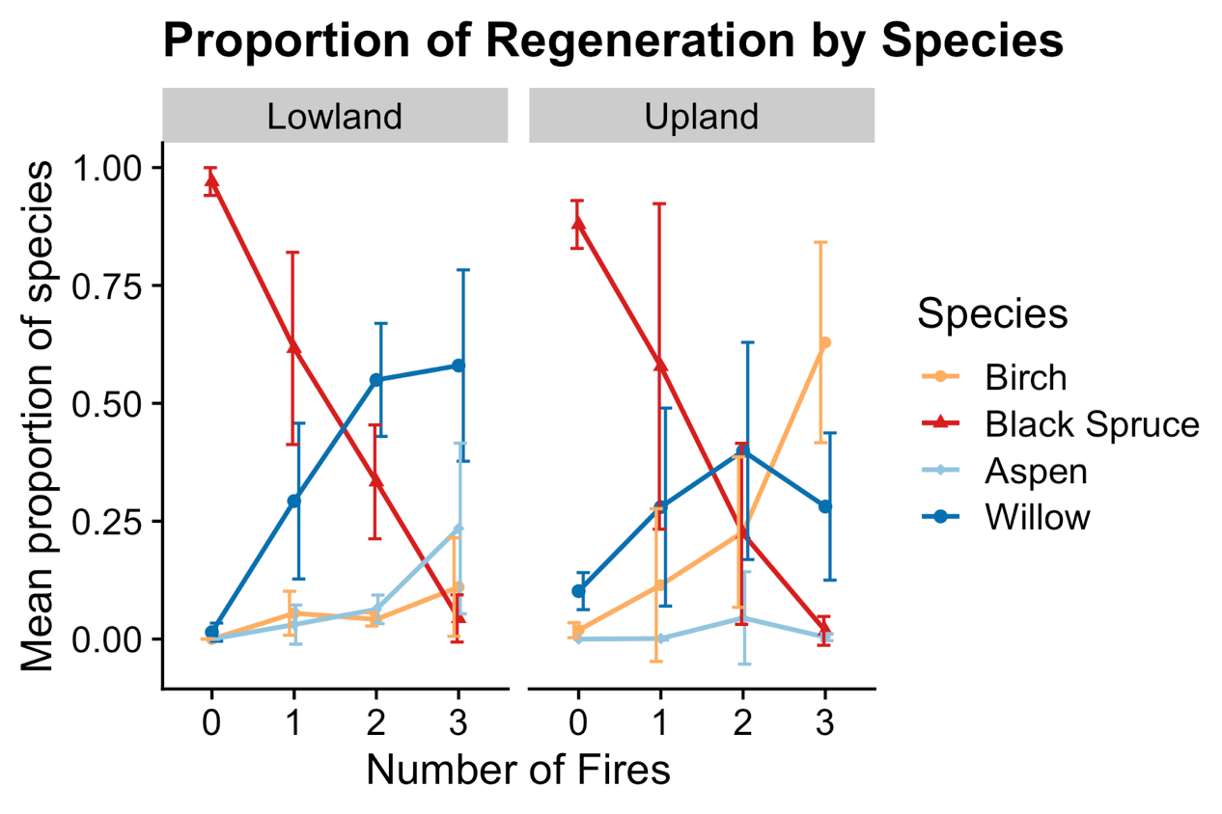

Figure 7.Soil characteristics in upland and lowland plots. A) Inferred soil consumption: distance in centimeters between highest adventitious black spruce roots to soil surface according to number of fires. B) Depth of organic layer (cm) in upland and lowland plots according to reburn sequence. C) Percent cover of exposed mineral soil in upland and lowland plots across reburn sequence.

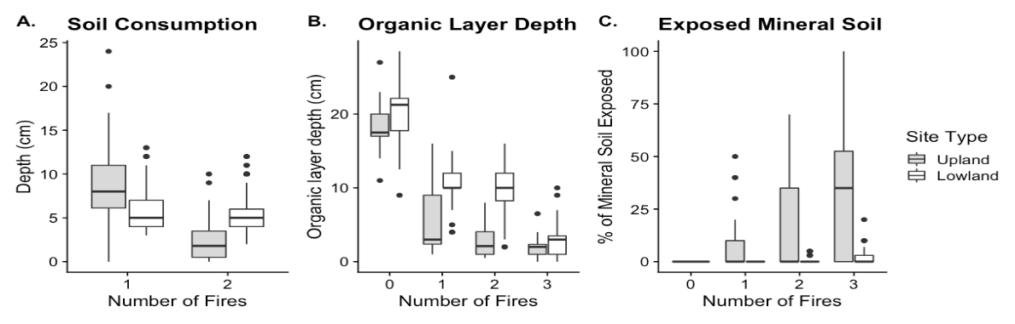

Table 1. Parameters of fire-regeneration models (regen = fires + site + (1 | plot ID number) with bootstrapped CI, df and p-values based on Wald approximation. Effects of fire and topographic position on post-fire density (stems/Ha) and basal area (m2/Ha) of conifer and deciduous trees. Topographic position abbreviated to ‘site’.

|  |  |  |  |  |  |  |  |  |
| --- | --- | --- | --- | --- | --- | --- | --- | --- |
| Metric | Division | Effect | Coeff. | SE | 95% CI | t | df | p |
| Density | Conifer | Intercept | 44.97 | 19.95 | (5.87, 84.07) | 2.25 | 496 | 0.024 |
| Fire # | -16.02 | 9.43 | (-34.5, 2.46) | -1.7 | 496 | 0.089 |
| Decid. | Intercept | -309.64 | 563.41 | (-1413.9, 794.63) | -0.55 | 496 | 0.583 |
| Fire # | 678.82 | 266.25 | (156.98, 1200.66) | 2.55 | 496 | 0.011 |
| Basal Area | Conifer | Intercept | 7.03 | 3.75 | (-0.32, 14.38) | 1.87 | 496 | 0.061 |
| Fire # | -2.65 | 1.77 | (-6.12, 0.83) | -1.49 | 496 | 0.136 |
| Decid. | Intercept | 0.2 | 0.31 | (-0.4, 0.8) | 0.65 | 163 | 0.52 |
| Fire # | 0.33 | 0.14 | (0.06, 0.6) | 2.37 | 163 | 0.02 |
| Site | -0.53 | 0.23 | (-0.97, -0.08) | -2.31 | 163 | 0.02 |

Table 2. Best fitting multivariate linear mixed-effect models describing post-fire stem density (stems/Ha) and basal area (m2/Ha) for conifer and deciduous regeneration across growth forms. Abbreviations are the following: ‘OL_AV’ for organic layer depth, “EXP_MIN” for exposed mineral soil, “SOLAR” for annual average solar radiation. Full model parameters in Table S7.

|  |  |  |  |
| --- | --- | --- | --- |
|  | Metric | Model | Df |
| Conifer | Density | OL_AV + EXP_MIN + (1 | FIRE ) | 8 |
| BA | SLOPE + SOLAR + OL_AV + EXP_MIN + (1 | FIRE ) | 7 |
| Deciduous | Density | SLOPE + OL_AV + EXP_MIN + (1 | FIRE) | 9 |
| BA | SLOPE + OL_AV + EXP_MIN + (1 | SITE) | 6 |

Table 3. Direction and significance of effect sizes of topographic and soil attributes on regeneration of conifer and deciduous seedlings and trees. Significance of effect indicated as follows: *** p ≤ 0.001, ** p ≤ 0.01, * p ≤ 0.05. Stem densities represented by stems/Ha, basal area by m2/ha.

|  |  |  |  |  |  |
| --- | --- | --- | --- | --- | --- |
| Covariate | | Tree and Seedling Density | | Tree Basal Area | |
| *Conifer* | *Decid.* | *Conifer* | *Decid.* |
| Topographic Attrib. | Slope |  | + 484.77 *** | + 0.03 | -0.44 |
| Solar Radiation |  |  | + 0.01 |  |
| Soil Attrib. | Av. OL Depth | - 11.82 * | - 349.84 * | - 0.00 | -0.36* |
| Av. Exp. Min. Soil | -5.09 | - 340.08 *** | -0.01 | 0.5** |

# Supplemental Materials

Table S1. Fire sequence, history and size across upland and lowland plots.

|  |  |  |  |  |  |
| --- | --- | --- | --- | --- | --- |
| Site | Plot ID # | # of Fires | Fire | Year | Fire Size (ac) |
| Upland | 12, 41, 48, 50, 52, 64, 65 | 1 | Fish Creek | 2005 | 101,585 |
| 42 | 1 | Erickson | 2003 | 117,156 |
| 56, 57, 47, 16, 8, 39 | 2 | Rogers | 1967 | 28,675 |
| Fish Creek | 2005 | 101,585 |
| 32, 40 | 2 | Rogers | 1967 | 28,675 |
| Erickson | 2003 | 117,156 |
| 7, 14, 15, 54, 55 | 3 | Rogers | 1967 | 28,675 |
| 132376 | 1991 | 55,978 |
| Fish Creek | 2005 | 101,585 |
| Lowland | 33, 29, 28, 18, 5 | 1 | Boglen Creek | 2004 | 201,894 |
| 20, 36 | 1 | Graveyard Creek | 2006 | 11,362 |
| 26, 27, 4, 3, 19 | 2 | Crazy Mountain | 1953 | 16,702 |
| Boglen Creek | 2004 | 201,894 |
| 34 | 2 | Central W-10 | 1957 | 49,701 |
| Boglen Creek | 2004 | 201,894 |
| 22, 17, 25, 35, 24, 23, 2 | 3 | Central W-10 | 1957 | 49,701 |
| Albert Creek | 1974 | 28,675 |
| Boglen Creek | 2004 | 201,894 |

Figure S1**.** Histograms of topographic variables of Upland and Lowland Plots. Dotted vertical lines represent mean of site. A) Distribution of slope (degrees) of plots. Upland plots were more steeply sloped on average than lowland plots. B) Histogram of plot elevation (meters above sea level). Lowland plots were generally lower in elevation than upland plots. C) Annual average solar radiation (watts per square meter). Upland plots received greater annual solar radiation on average than lowland plots.

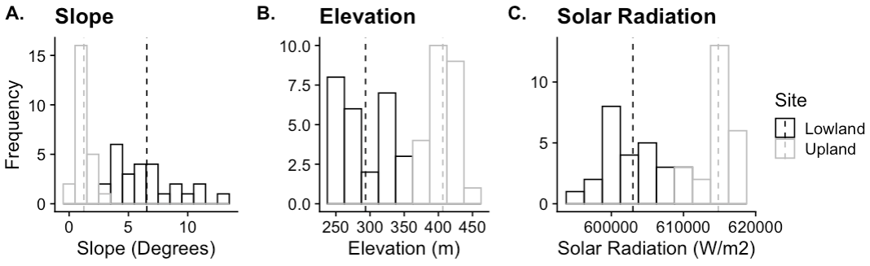

Table S2.Climate data from nearest Western Regional Climate Center monitoring station. Upland data comes from Seven Mile Alaska Station and Lowland data is from the Preacher Creek Station. Variables are averaged across data from January 1993 to January 2019. Winter temperature includes averages from October through March, while summer temperature extends from June through August.

|  |  |  |  |  |  |
| --- | --- | --- | --- | --- | --- |
| Metric | Site | Mean | SD | Max | Min |
| Annual Precipitation (in) | Upland | 7.4 | 3.4 | 14.6 | 3.4 |
| Lowland | 10.6 | 4.6 | 24.4 | 5.9 |
| Winter Temp | Upland | 7.1 | 18.9 | 46.8 | -28.4 |
| Lowland | 8.8 | 19.6 | 48.7 | -24.7 |
| Summer Temp | Upland | 50.4 | 13.6 | 68.6 | 18.3 |
| Lowland | 51.9 | 12.8 | 67.7 | 18 |

Table S3.Results from Moran’s I for spatial autocorrelation in density (stem count per hectare) and basal area (square meters per hectare) of trees within upland and lowland sites. Significant p-values marked in bold.

|  |  |  |  |  |  |  |
| --- | --- | --- | --- | --- | --- | --- |
| Site | Burn History | Variable | Observed | Expected | P-value | sd |
| Upland | 0 | Density | -0.02 | -0.02 | 0.88 | 0.02 |
| Basal Area | -0.01 | -0.07 | 0.26 | 0.05 |
| 1 | Density | -0.02 | -0.01 | 0.30 | 0.01 |
| Basal Area | -0.05 | -0.03 | 0.35 | 0.02 |
| 2 | Density | -0.02 | -0.01 | 0.37 | 0.01 |
| Basal Area | -0.01 | -0.03 | 0.51 | 0.03 |
| 3 | Density | -0.03 | -0.01 | **0.03** | 0.01 |
| Basal Area | -0.01 | -0.04 | 0.41 | 0.03 |
| Lowland | 0 | Density | -0.01 | -0.02 | 0.51 | 0.02 |
| Basal Area | -0.01 | -0.07 | 0.35 | 0.06 |
| 1 | Density | -0.01 | -0.01 | 0.61 | 0.01 |
| Basal Area | -0.01 | -0.04 | 0.42 | 0.04 |
| 2 | Density | -0.04 | -0.01 | **0.01** | 0.01 |
| Basal Area | -0.03 | -0.04 | 0.80 | 0.04 |
| 3 | Density | -0.003 | -0.01 | 0.40 | 0.01 |
| Basal Area | -0.01 | -0.03 | 0.40 | 0.02 |

Table S4.Current composition of canopy and understory. Average relative proportion of trees and seedlings of all species between upland and lowland sites and across reburn sequence. Species not present at a given site not included. Bolded numbers represent species most present on average within site and number of fires.

|  |  |  |  |  |  |  |
| --- | --- | --- | --- | --- | --- | --- |
| Fires | Site | Species | Tree % | Tree SD (%) | Seedling % | Seed SD (%) |
| 0 | Upland | *B. neoalaskana* | 2.8 | 2.1 | 0.7 | 1.4 |
| ***P. mariana*** | **91.7** | **2.7** | **86.8** | **11.5** |
| *Salix* | 5.4 | 3.3 | 12.5 | 10.2 |
| Lowland | ***P. mariana*** | **99** | **0.7** | **98.1** | **3.8** |
| *Salix* | 0.9 | 0.7 | 1.9 | 3.8 |
| 1 | Upland | *A. crispa* | 14.4 | 11.5 | 7.6 | 16 |
| ***B. neoalaskana*** | **22.6** | **30.8** | 13.7 | 16.6 |
| *P. mariana* | 6.5 | 10.6 | **51.8** | **37.6** |
| *Salix* | 13.1 | 21.4 |  |  |
| Lowland | *A. crispa* | 14 | 21.9 | 0.4 | 1 |
| *B. glandulosa* | 5 | 11.2 |  |  |
| *B. neoalaskana* | 25 | 43.3 | 3.9 | 4.3 |
| *P. mariana* | 16 | 35.8 | **62.4** | **18.9** |
| *P. tremuloides* |  |  | 2.7 | 4.04 |
| ***Salix*** | **40** | **54.8** | 30.6 | 15.8 |
| 2 | Upland | *A. crispa* | 15 | 26.4 | 6.7 | 13.8 |
| ***B. neoalaskana*** | **62.2** | **24.7** | 8 | 10.8 |
| *P. glauca* |  |  | 7.3 | 20.5 |
| *P. mariana* |  |  | 29 | 23.3 |
| *P. tremuloides* | 0.8 | 2.5 | 12 | 31.5 |
| *Salix* | 21.9 | 17.8 | **36.9** | **30** |
| Lowland | *A. crispa* | 25 | 50 | 0.3 | 0.5 |
| *B. glandulosa* |  |  | 0.8 | 1.4 |
| ***B. neoalaskana*** | **50** | **40.8** | 3.7 | 1.4 |
| *P. mariana* |  |  | 33.8 | 12.3 |
| *P. tremuloides* |  |  | 6.3 | 3.1 |
| *Salix* | 25 | 28.9 | **55** | **12.5** |
| 3 | Upland | *A. crispa* | 21 | 26.5 | 4.8 | 6.19 |
| ***B. neoalaskana*** | **50** | **35.7** | **57.9** | **30.8** |
| *P. mariana* |  |  | 2.3 | 3.2 |
| *P. tremuloides* |  |  | 0.2 | 0.4 |
| *Salix* | 29 | 17.5 | 34.7 | 29 |
| Lowland | *A. crispa* |  |  | 0.3 | 0.5 |
| *B. glandulosa* | 3.4 | 8.9 | 2.8 | 3.5 |
| *B. neoalaskana* | 6.4 | 6.4 | 11.6 | 11 |
| *P. balsamifera* | 0.8 | 2.2 |  |  |
| *P. mariana* |  |  | 4.9 | 5.6 |
| ***P. tremuloides*** | **49** | **31.4** | 21.1 | 18 |
| *Salix* | 40.3 | 24.1 | **59.3** | **21.9** |

Table S5. Results from comparison of conifer and deciduous tree basal area (m2/Ha) and densities of conifer and deciduous trees (stem/ha) across reburn sequence and between topographic position using Dunn’s multiple pairwise comparison test. P-values adjusted with Holm-Bonferonni correction. Only sequential comparison results presented. Significance of effect indicated as follows*** p ≤ 1e-04, ** p ≤ 0.01, * p ≤ 0.05.

|  |  |  |  |  |  |  |  |  |  |
| --- | --- | --- | --- | --- | --- | --- | --- | --- | --- |
| Metric | Division | Site | Comparison | n1 | n2 | statistic | p | Adjust. p | Sig |
| Density | Conifer | Upland | 1 vs 2 | 80 | 80 | -3.78 | 1.5e-4 | 3.1e-4 | *** |
| 2 vs 3 | 90 | 60 | -1.12 | 0.26 | 0.26 |  |
| Lowland | 1 vs 2 | 98 | 84 | -1.46 | 0.14 | 0.29 |  |
| 2 vs 3 | 84 | 98 | 2.33 | 0.02 | 0.06 |  |
| Deciduous | Upland | 1 vs 2 | 80 | 80 | 6.59 | 4.4e-11 | 1.3e-10 | *** |
| 2 vs 3 | 80 | 60 | 0.17 | 0.87 | 0.87 |  |
| Lowland | 1 vs 2 | 98 | 84 | 0.55 | 0.58 | 0.58 |  |
| 2 vs 3 | 84 | 98 | 8.25 | 1.64e-16 | 3.29e-16 | *** |
| Basal Area | Conifer | Upland | 1 vs 2 | 8 | 8 | -1.73 | 0.08 | 0.17 | * |
| 2 vs 3 | 8 | 6 | -0.53 | 0.59 | 0.59 |  |
| Lowland | 1 vs 2 | 6 | 6 | 0.17 | 0.86 | 0.86 |  |
| 2 vs 3 | 6 | 8 | 0.90 | 0.37 | 0.83 |  |
| Deciduous | Upland | 1 vs 2 | 8 | 8 | 2.69 | <0.01 | 0.02 | * |
| 2 vs 3 | 8 | 6 | -0.33 | 0.74 | 0.74 |  |
| Lowland | 1 vs 2 | 6 | 6 | -0.63 | 0.53 | 0.53 |  |
| 2 vs 3 | 6 | 8 | 2.75 | <0.01 | 0.02 | * |

Table S6.Model selection parameters from competing interacting and non-interacting models of the effect of fire number and topographic position on tree regeneration. Topographic position abbreviated to ‘site’ and number of fires abbreviated to ‘fire’. Best fitting model shown in bold.

|  |  |  |  |  |  |  |  |
| --- | --- | --- | --- | --- | --- | --- | --- |
| Metric | Division | Model | df | AIC | BIC | Chi-Sq | p |
| Density | Conifer | **fire + (1 | plot ID)** | **4** | **5180** | **5197** |  |  |
| site + (1 | plot ID) | 4 | 5183 | 5200 | 0 | 1 |
| site + fire + (1 | plot ID) | 5 | 5182 | 5203 | 2.94 | 0.9 |
| site*fire + (1 | plot ID) | 6 | 5184 | 5209 | 0.08 | 0.77 |
| Decid. | **fire + (1 | plot ID)** | **4** | **8493** | **8510** |  |  |
| site + (1 | plot ID) | 4 | 8498 | 8515 | 0 | 1 |
| site + fire + (1 | plot ID) | 5 | 8493 | 8514 | 7.068 | 0.01 |
| site*fire + (1 | plot ID) | 6 | 8494 | 9519 | 0.34 | 0.56 |
| Basal Area | Conifer | **fire + (1 | plot ID)** | **4** | **2407** | **2424** |  |  |
| site + (1 | plot ID) | 4 | 2409 | 2426 | 0 | 1 |
| site + fire + (1 | plot ID) | 5 | 2408 | 2429 | 2.45 | 0.11 |
| site*fire + (1 | plot ID) | 6 | 2409 | 2435 | 0.84 | 0.36 |
| Decid. | fire + (1 | plot ID) | 4 | 614.2 | 626.7 |  |  |
| site + (1 | plot ID) | 4 | 614.4 | 626.9 | 0 | 1 |
| **site + fire + (1 | plot ID)** | **5** | **610.8** | **626.4** | **5.61** | **0.02** |
| site*fire + (1 | plot ID) | 6 | 612.8 | 631.5 | 0.02 | 0.9 |

Table S7.Parameters of site attribute regen models including bootstrapped CI, t, df and p-values based on Wald approximation. Significant p-values are in bold.

|  |  |  |  |  |  |  |  |  |
| --- | --- | --- | --- | --- | --- | --- | --- | --- |
| Metric | Division | Effect | Coeff. | SE | 95% CI | t | df | p |
| Density | Conifer | Intercept | 9.27 | 12.36 | (-14.96, 33.5) | 0.75 | 495 | 0.45 |
| Av. OL | - 11.82 | 5.32 | (-22.25, -1.39) | - 2.22 | 495 | **0.03** |
| Exp. Min | - 5.09 | 2.77 | (-10.52, 0.34) | - 1.84 | 495 | **0.01** |
| Decid. | Intercept | 888.67 | 850.1 | (202.49, 1574.86) | 2.54 | 494 | **0.01** |
| Slope | 484.77 | 87.76 | (312.76, 656.78) | 5.52 | 494 | **<.01** |
| Av. OL | - 349.84 | 144.92 | (-633.88, -65.80) | -2.41 | 494 | **0.02** |
| Exp. Min | -340.08 | 86.91 | (-510.43, -169.73) | -3.91 | 494 | **<.01** |
| Basal Area | Conifer | Intercept | 0.04 | 0.05 | (-0.05, 0.13) | 0.85 | 35 | 0.39 |
| Slope | 0.01 | 0.06 | (-0.10, 0.12) | 0.19 | 35 | 0.85 |
| Solar | 0.03 | 0.05 | (-0.08, 0.14) | 0.54 | 35 | 0.59 |
| Av. OL | 0.00 | 0.04 | (-0.08, -0.07) | -0.13 | 35 | 0.89 |
| Exp. Min | -0.01 | 0.04 | (-0.09, 0.07) | -0.22 | 35 | 0.82 |
| Decid. | Intercept | 0.79 | 0.3 | (0.2, 1.38) | 2.62 | 120 | **<.01** |
| Slope | -0.44 | 0.22 | (-0.87, 0.00) | -1.96 | 120 | **0.05** |
| Av. OL | -0.46 | 0.16 | (-0.68. -0.04) | -2.23 | 120 | **0.03** |
| Exp. Min | 0.5 | 0.18 | (0.15, 0.85) | 2.82 | 120 | **<.01** |